**Project Design Phase-II Technology Stack (Architecture & Stack)**

|  |  |
| --- | --- |
| Date | 19 October 2022 |
| Team ID | PNT2022TMID34283 |
| Project Name | Project - Real-Time Communication System Powered by AI for Specially Abled |
| Maximum Marks | 4 Marks |

# Technical Architecture:

The Deliverable shall include the architectural diagram as below and the information as per the table1 & table 2

# Example: Real-Time Communication System Powered by AI for Specially Abled

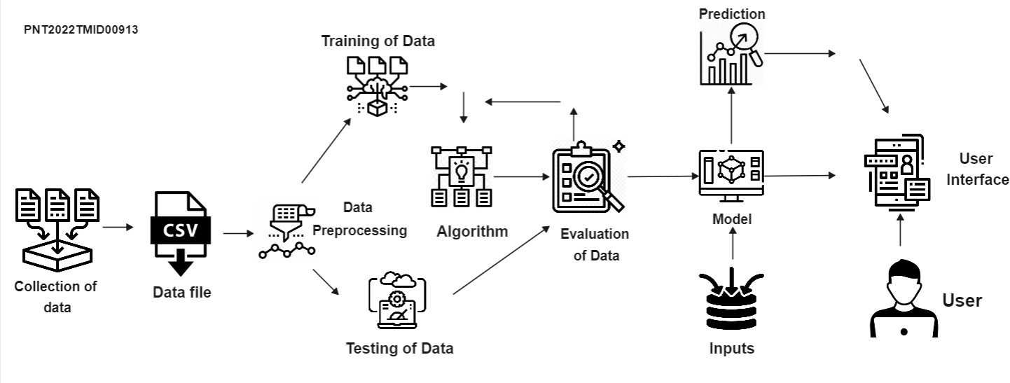

**Table-1 : Components & Technologies:**

|  |  |  |  |
| --- | --- | --- | --- |
| **S.No** | **Component** | **Description** | **Technology** |
| 1. | Collection of data | Collection of the All type of hand signs photos and videos from various resources | Can be collected from internet |
| 2. | Data File | Convert the collected data into CSV file | Online Converter |
| 3. | Data Preprocessing | Data preprocessing is the process of transformin raw data into a useful, understandable format. | Sampling Data |
| 4. | Training | Training data is the data you use to train an algorithm or machine learning model to predict the outcome you design your model to predict. | NLP[ Natural Language Processing] |
| 5. | Testing | Testing data is where the preprocessed data model will be tested | NLP[ Natural Language Processing] |
| 6. | Evaluation | Records the result of generalization accuracy of the proposed model |  |
| 7. | Inputs | Where the samples inputs of hand signs can be provided though the camera | Image processing |
| 8. | Model | Algorithms like DeepASL are applied to classify the given image dataset | Deep learning |
| 9. | Prediction | The attributes extracted from the images are examined and predictions are made in order to convert the sign-language to the corresponding  Voice | Deep learning |
| 10. | User | Deaf and Dumb people can communicate with normal people with user-interface application by their sign language and this will be  converted into voice mode at the other end. | AI Techniques |

**Table-2: Application Characteristics:**

|  |  |  |  |
| --- | --- | --- | --- |
| **S.No** | **Characteristics** | **Description** | **Technology** |
| 1. | Open-Source Frameworks | Bots and various other AI tools have been successful It is possible for  people with disabilities to live at ease. | AI techniques like self-moving robots and other software systems |
| 2. | Security Implementations | The authentication process uses the  username/password pair of the user or the OTP sent to the mobile number register by the user. | SHA-1, Encryptions, IAM Controls |
| 3. | Scalable Architecture | The user might get toll free number for any queries and video tutorial will acts as there guide. Customer support is enabled in the  application for 24*7. | Presentation layer, Application layer and Data Layer modularity, Docker |
| 4. | Availability | When application sever downs, the load balancer transfers requests to other machines  that are available. | Key performance indicators (KPI) |
| 5. | Performance | The application performs efficiently under a heavy load of translation requests without any significant  reduction in the conversion accuracy | Number of requests per minute, accuracy of translation (sign-language  to speech & text to sign-language) |